[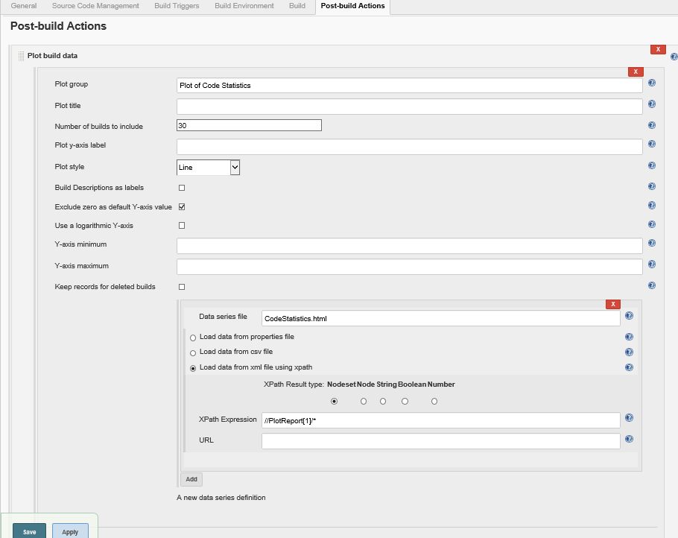](http://dldz2lhm2:8080/job/CodeStatistics/configure)

Code statistic config

[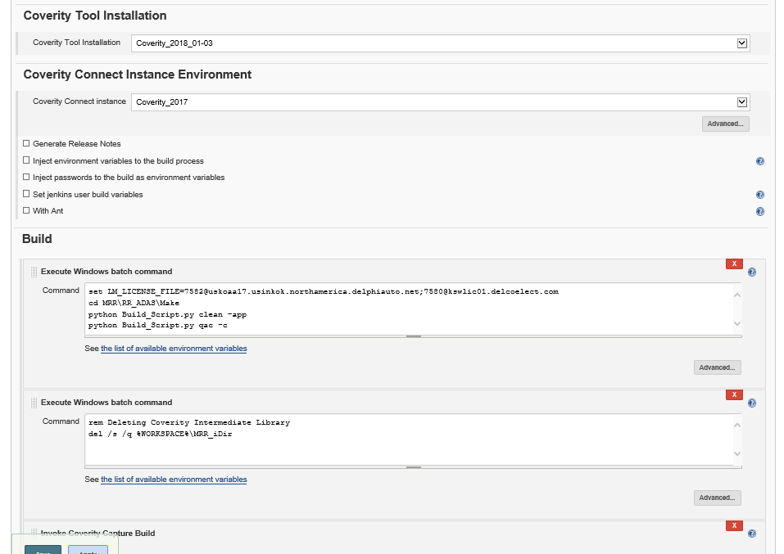](http://dldz2lhm2:8080/job/Coverity_DAT_2.0_MRR/configure)

[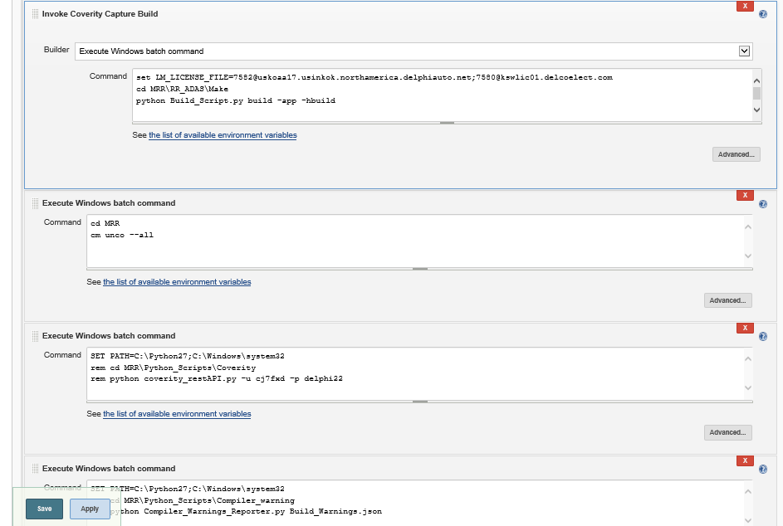](http://dldz2lhm2:8080/job/Coverity_DAT_2.0_MRR/configure)

[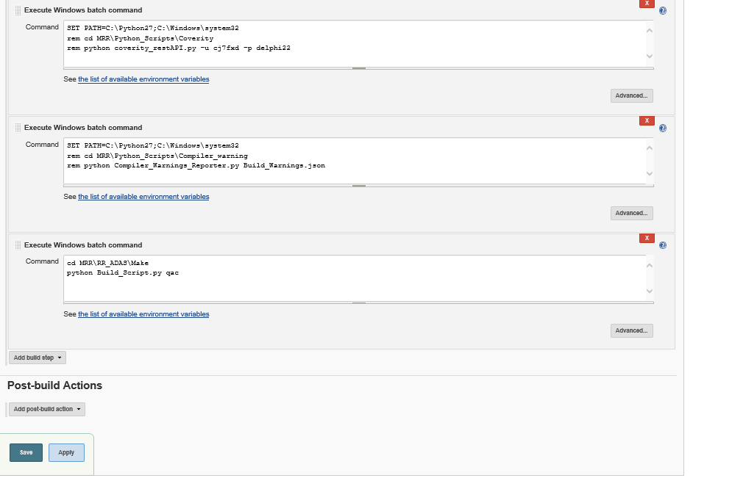](http://dldz2lhm2:8080/job/Coverity_DAT_2.0_MRR/configure)

[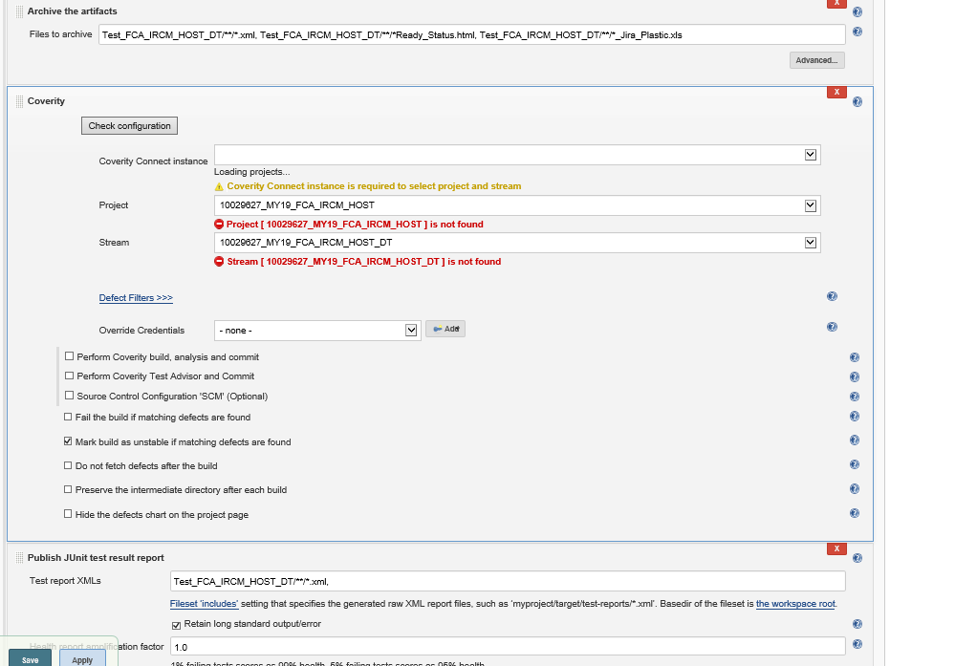](http://dldz2lhm2:8080/job/FCA_Demo/configure)

[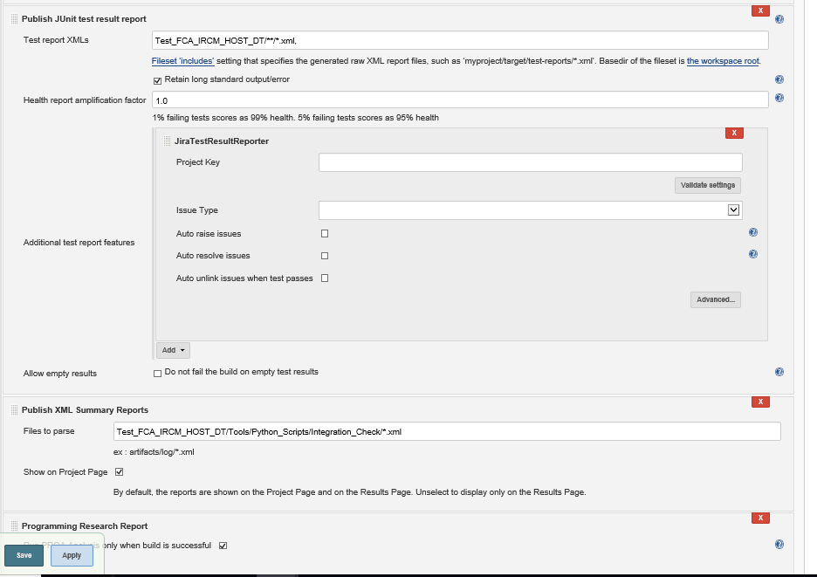](http://dldz2lhm2:8080/job/FCA_Demo/configure)